TATHRA AMATEUR FISHING CLUB INC  www.tathrafishingclub.com.au  Treasurer - Greg McKay Email: treasurer@tathrafishingclub.com.au | 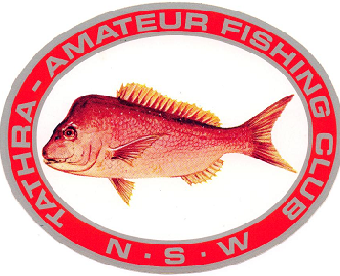

MEMBERSHIP INVOICE 2026-2027
Please note when paying your fees
• Children 15 and Under are FREE. However, Names and DOB must be included
• Game Fishing Affiliation is an optional extra
• PLEASE MAKE ANY NECESSARY CHANGES AND RETURN
Name: | TAFC Radio Number:
Email:
Postal Address:
State: | Postcode:
Phone:
Social Member 1:
Social Member 2:
Children 15 and under
Name: | DOB:
Name: | DOB:
Name: | DOB:
BOAT DETAILS
Name & Boat Rego: | Trailer Rego:
Make: | Length:
Aluminium/Glass: | Colour:
Notes:

Annual Membership | $60.00
Joining Fee (New Members) | $ 5.00
Social Membership | $10.00
Student Membership (16-18yrs) | $20.00
Junior Membership | 0.00
Game Fishing Affiliation (Senior From 16yrs +) | $60.00
Game Fishing Affiliation (Junior & Small Fry up to 15yrs) | 0.00
Membership Sub-Total |  | $
Club Items
Jacket (Size 14-28) Amount: | $65.00
Game Fishing Shirt (Size 8, 10, 12, S, L, XL) Amount: | $60.00
Maroon Polo Shirt with Logo (Size Small to XXL) Amount: | $25.00
TAFC Cap Amount: | $15.00
Club Logo Snapper Sticker Amount: | $ 5.00
Merchandise Sub-Total | Clothing Total | $
Please Add Postage For Merchandise | $18.00
PAYMENT IS STRICTLY WITHIN 14 DAYS OF INVOICE | Total | $
Payment Options:
• Online: Please include your name and radio number so we can identify your payment.
Account Name: Tathra Amateur Fishing Club Inc
Institution: Commonwealth Bank
BSB: 062505 Account No: 00900871
Mail: Cheques/money orders to be made payable to Tathra Amateur Fishing Club Inc
Post to: PO Box 7005 Tathra NSW 2550
Treasurer - Greg McKay | Email: treasurer@tathrafishingclub.com.au

